Kindergarten Supplies
Unity Point School 2016-2017

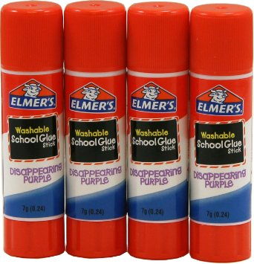
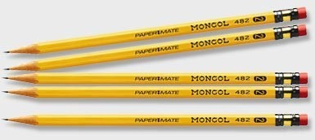
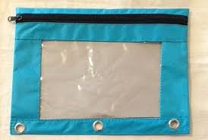
1 pencil pouch with zipper 5 Sharpened Pencils 4 Elmer’s glue sticks .77 oz. (large)

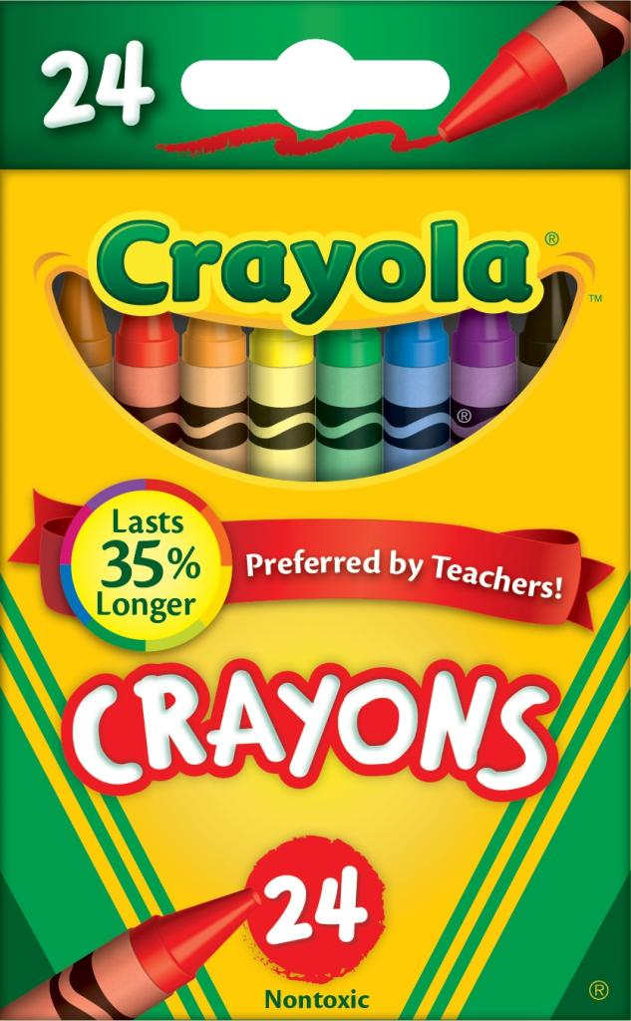
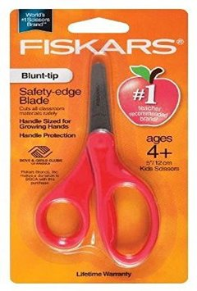
1 safety cut scissors 1 box of no more than 24 crayons

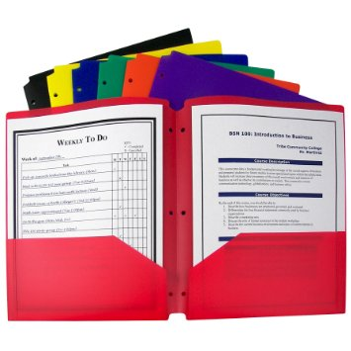
2 large boxes of Kleenex 2 poly/vinyl two pocket folder 1 set of headphones
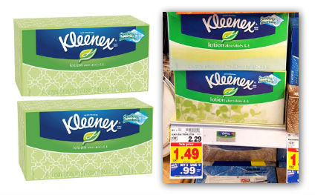
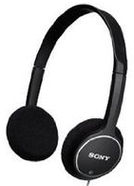

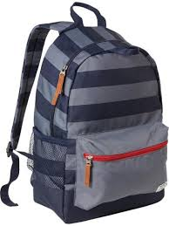
1 1 inch three ring binder 1backpack or school bag (big enough for 2-pocket folders)
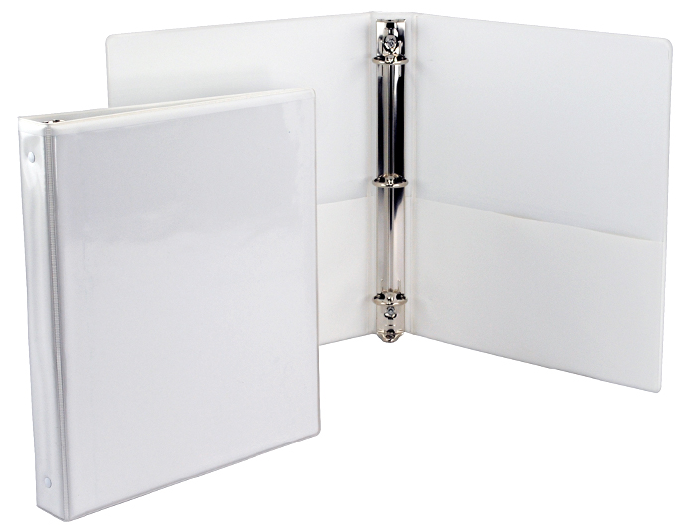

Additional classroom needs (optional):
Baby wipes disinfecting wipes gallon zip lock bags sandwich size zip lock bags
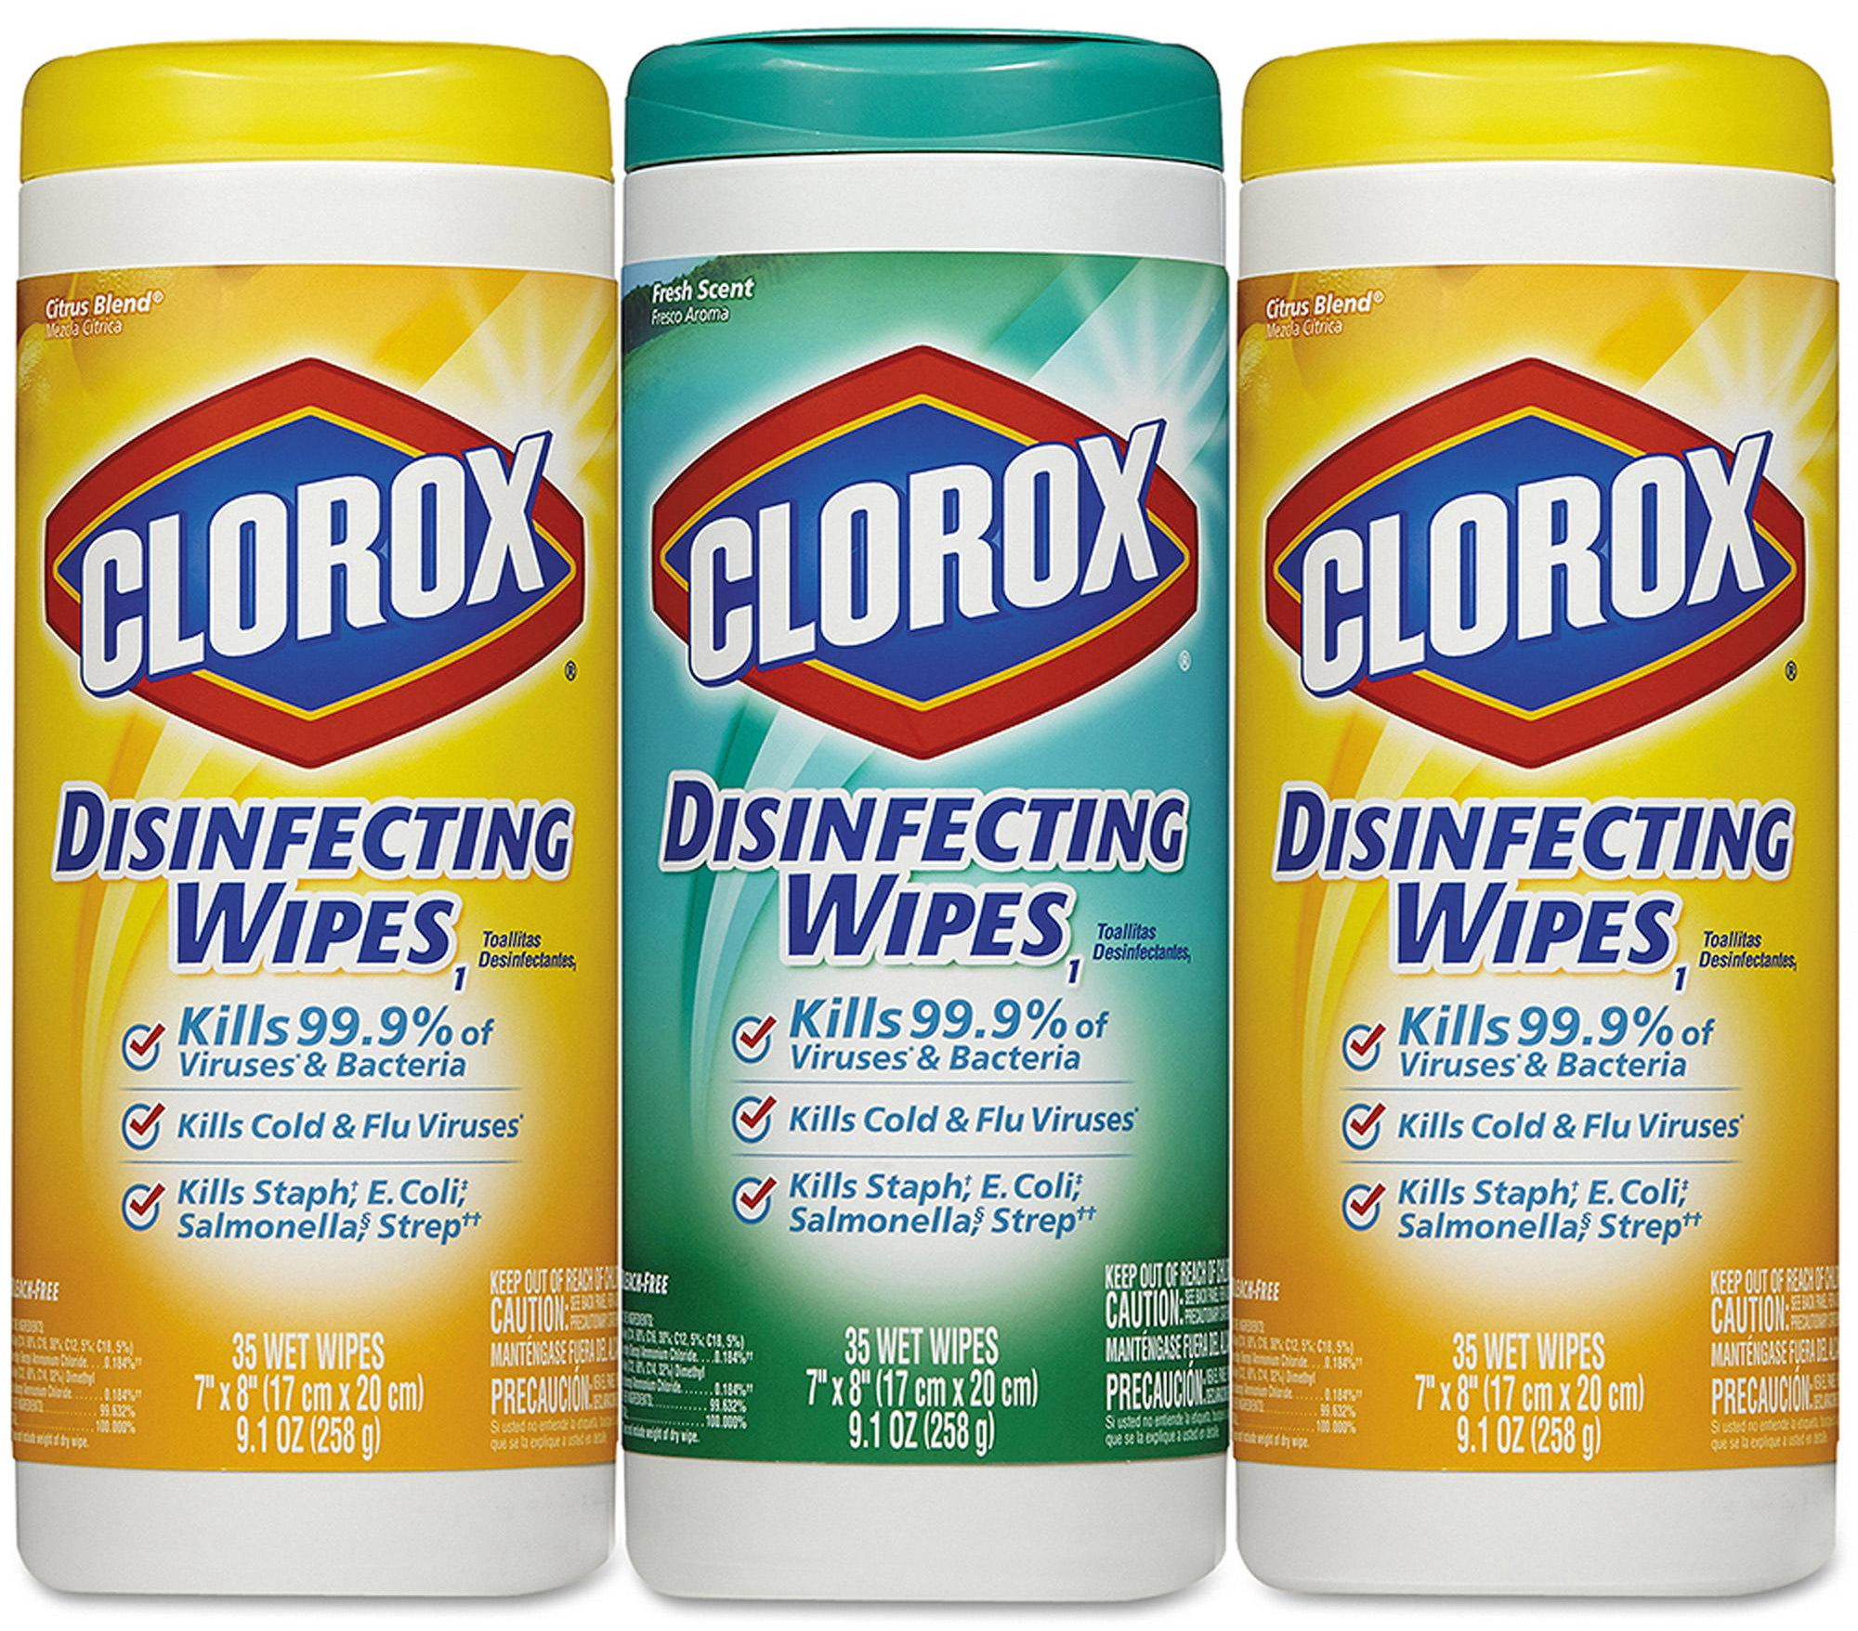
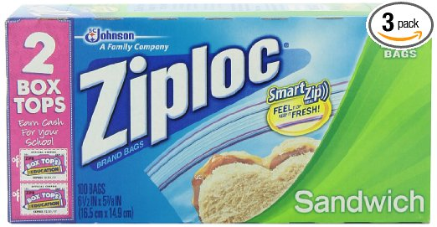
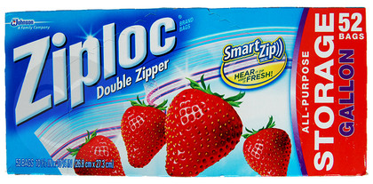
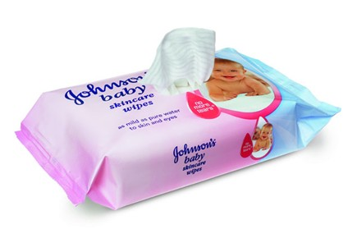

Important:
Each student will need a large zip-lock bag with a change of clothing in it.
(Please do not send extra clothes in boxes).

Please take time to write your child’s name on everything, even coats, hats and mittens.

☼ If you have any questions about the above items please visit the U.P. kindergarten website.

Your child will receive a colored name badge in the mail before school starts. We ask that your child wear this badge the first two weeks of school to help bus drivers, teachers and Unity Point staff identify our newest students
Thank You.

