“Family Chatters”  “Family Chatters” is a time to gather together to discuss the many new experiences children ages birth to five encounter. | 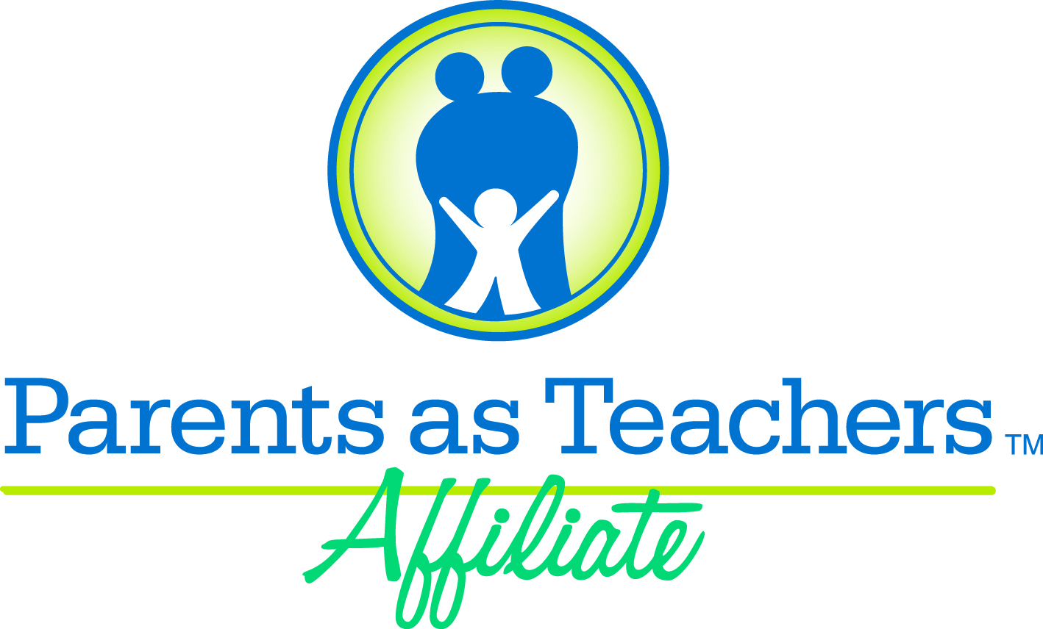

“Family Chatters” is a special program for Unity Point families that have children ages birth to 5 years.  Join us as we share our experiences and enjoy refreshments  You will also be entered for a chance to win a door prize. | Spring 2018  “Family Chatters”  Schedule

“Family Chatters” provides:  - Opportunities to ask questions and discuss challenges you are facing with your child;  - Information about how children  grow, develop & learn;  - A way to meet new friends  and share good ideas.
  WHERE:  Unity Point School  Pre-k Conference Room  The Pre-k Conference Room is located in the hallway next to the Pre-K classrooms.  WHEN:  9:00 to 11:00 | Fridays:  January  12th  (Nutrition)  February  16th  (Dental Health)  March  1st  (Dr. Seuss’s Birthday/6-7:30pm)  April  14th  (Family Day Out/1:00-3:00pm)  May  18th  (Emergency Planning)
Childcare is provided for children ages 12-36 months.
Limited spaces are available.
Please call 529-4151 ext. 210
for child care reservations.

If you require child care please arrive
in the Birth-To-Three Classroom by 8:45.

If you do not need child care please meet
in the Pre-k Conference Room by 9:00.

For more information call 529-4151:
ext. 210 for Chevelle, cbartlett@up140.org or ext. 209 for Kim, kdavidson@up140.org
OR visit the Family Center located behind the school.

\\Adserver\shared folders\Family Circle\0-3\Friday Programs\Family Chatters\2011 Familly Chatters fall Schedule.doc. 11/22/2026

